**Haier HWD-3025D Water Dispenser**

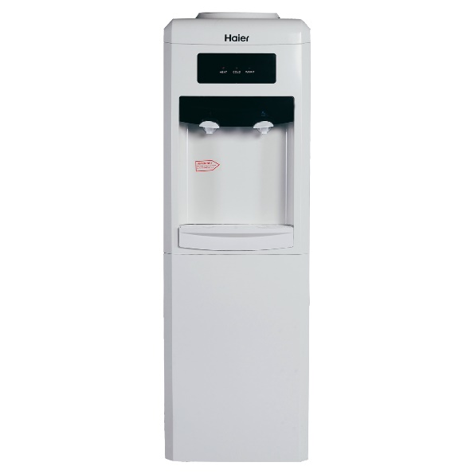

|  |  |
| --- | --- |
| **Type:** | Floor Standing |
| **Water Supply(l):** | 7.5+ |
| **Weight(kg):** | 21 |
| **Unit Dimensions(H*W*L)mm:** | Unspecified |
| **Power Supply:** | 80W-500 |
| **Filter Stages:** | 3 |